liman irrigation system

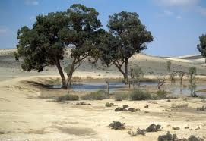  liman irrigation system, Wikepedia, English, http://en.wikipedia.org/wiki/Liman_irrigation_system,  http://upload.wikimedia.org/wikipedia/commons/a/ae/Jewish_National_Fund_trees_in_The_Negev.jpg | 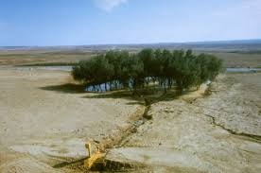  http://www.kkl.org.il/eng/people-and-environment/think-environment-think-kkl-jnf ,  http://www.kkl.org.il/eng/files/category-afforestation/liman_negev_albatros.jpg
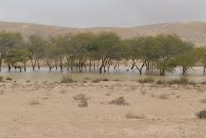  http://www.kkl.org.il/eng/about-kkl-jnf/kkl-jnf-year-to-year/kkl-111-years,  http://www.kkl.org.il/eng/files/about_kkl/KKL111/liman-small.jpg | 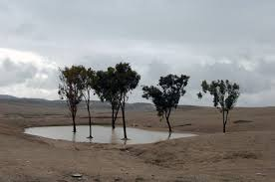  http://www.kkl.org.il/eng/about-kkl-jnf/kkl-jnf-in-public-discourse/in-the-press/oct-dec-2012/desert-conf,  http://www.kkl.org.il/eng/files/desertification/environment_desertification_liman.jpg
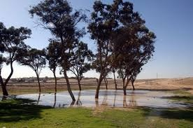  http://www.kkl.org.il/eng/about-kkl-jnf/green-israel-news/january-2013/winter-israel,  http://www.kkl.org.il/eng/files/News_archive/January2013/Winter/Liman6-pnina.JPG | 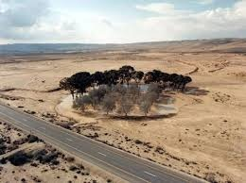  http://alethonews.wordpress.com/2014/01/05/no-dams-in-the-negev-anatomy-of-a-hasbara-swarm,  http://richardedmondsondotnet.files.wordpress.com/2014/01/liman.jpg

