REBUILDING IN THE






AFTERMATH OF AN
EARTHQUAKE
USING LOCAL SKILLS AND KNOWLEDGE
Introduction
Building technologies in development projects are often developed to be used on a small, local scale. Even when working on a huge project, Bashir Sakhawarz was convinced of the need to take local construction practices, resources, skills, and needs into account, when creating new settlements that will be sustainable and safe. While it was imperative to respond to the needs of disaster victims as quickly and humanely as possible, beneficiaries' skills, knowledge of local construction practices, and resources had to be taken into account.
On 30 September 1993, an earthquake in the Marathwada region rocked large areas of Maharashtra and Karnataka, particularly the settlements located in Latur and Osmanabad districts of Maharashtra. Nearly 10 000 people were killed and as many were injured. Countless houses, buildings, and infrastructure works were seriously damaged. Buildings were damaged extensively in 83 villages, of which 25 suffered near-total destruction.
Figure 1: Many traditional stone and earth buildings are not built to withstand seismic activity, and are prone to crack and even collapse.

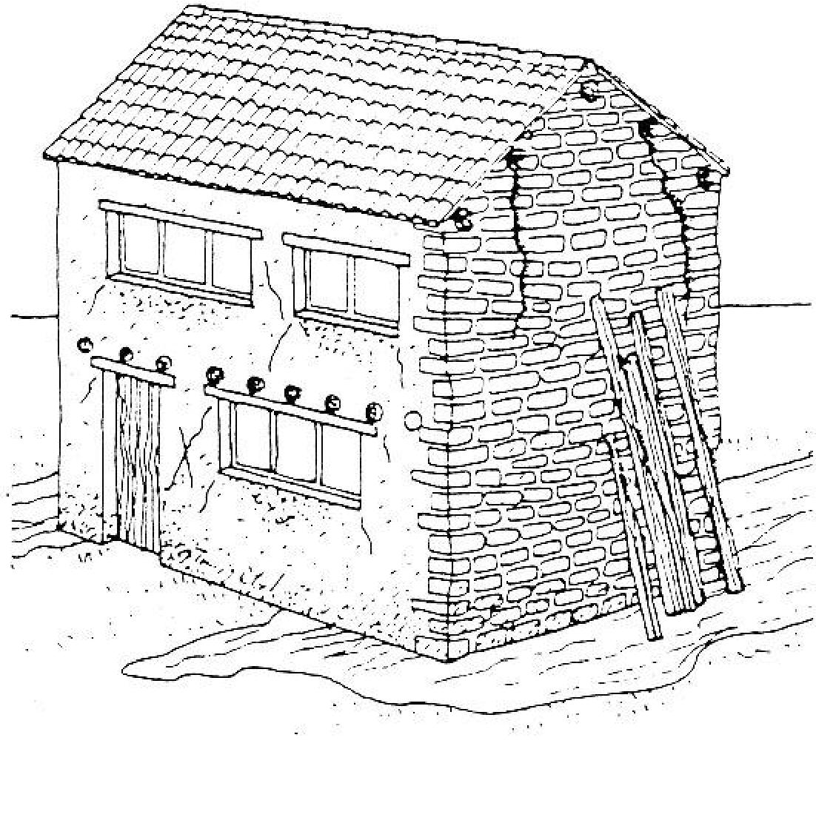
The devastation was so great that the Indian government asked for help from the international community to undertake a rehabilitation and reconstruction programme. The International Red Cross provided about £7 million -about 5 per cent of the overall costs -and the World Bank provided the remainder. The scale of the reconstruction needed meant that the whole project would be overseen by the government. The Building Material and Technology Promotion Council commissioned a team of professionals, known as TARU -the Technology Section Research Unit for Development, who undertook a rapid assessment of the damaged houses and buildings in the affected areas. Three teams of professionals made up of geologists, architects, civil engineers, sociologists, and management consultants visited the villages to study the cause and pattern of the damage, and to recommend cost-effective and appropriate technical strategies for house construction on new sites, and for the retrofitting and seismic strengthening of the various types of houses on the existing sites. The region may continue to be prone to earthquake tremors, so the technical options recommended conformed to standards for housing and buildings in Zone 4 of the earthquake zone map of the Bureau of Indian Standards. The villagers were not required to pay for any of the rebuilding.
Practical Action, The Schumacher Centre, Bourton on Dunsmore, Rugby, Warwickshire, CV23 9QZ, UK
T +44 (0)1926 634400 | F +44 (0)1926 634401 | E infoserv@practicalaction.org.uk | W www.practicalaction.org
Practical Action is a registered charity and company limited by guarantee.
Company Reg. No. 871954, England | Reg. Charity No.247257 | VAT No. 880 9924 76 | Patron HRH The Prince of Wales, KG, KT, GCB
Local decisions
Rebuilding after an earthquake Practical Action
2
Once the initial surveys had taken place, the team set out to design a process that would ensure that the communities were involved as much as possible in planning their new villages and houses. The scale of building required about 80 villages for 200 000 people -meant that the villagers were going to have to work together with professional builders. In many villages every house had collapsed and rubble was strewn everywhere, and the need to provide shelter as soon as the communities felt able to make decisions about abandoning villages and relocating, or rebuilding on the site of such devastation and death meant that outside workers were going to be involved as well.

The government set up and managed a rehabilitation centre, to which each community was invited to send a representative. There the villagers discussed with the architects, planners, and builders the options for rebuilding. Many villages had to be relocated, so they talked about and decided where the new villages would be, how large they would be, and what type of school, community centre, and health centre they wanted. They planned the layout of the new (or rebuilt) villages, including infrastructure such as roads and water and electricity supply.
The most common failures in damaged buildings were the shattering and buckling of the outer face of stone masonry walls because of the lack of through stones, and corner failure in stone and brick masonry. Many walls had collapsed, including load-bearing walls, and there were also many partial and total roof collapses. In RCC (reinforced cement concrete) structures the shear failure of brick masonry was apparent where there was a vertical opening between brick joints. Surprisingly, foundation settlement was uncommon in most of these houses.
A number of technical options for repairing non-engineered constructions and rebuilding were examined, including seismic- resistant building technologies that have been developed and promoted by various agencies. Traditional and improved traditional construction technologies were also evaluated. The criteria for evaluating the technologies included:
Structural safety Technologies must meet the all structural requirements for seismic zone 4 of the National Building Code.
Thermal comfort Houses must have adequate insulation and ventilation.
Maintainability Structures must be able to be maintained locally, and upgraded. Cost effective The life cycle cost of the buildings should be as low as possible.
The cluster of technologies that emerged as the most appropriate for new construction in the region were:
Walling Graded stone/concrete blocks and concrete hollow blocks: and
Roofing Shabad stone (a local material) on steel grilling, pre-cast RCC planking on precast joists, and RCC slabs cast in-situ.
Existing and traditional conditions
The affected area was connected by road to the Solapur-Hyderabad highway, which passes through Omerga town in the Osmanabad district. Omerga is l70km from Hyderabad. In this gently undulating hard rock terrain, with variable thicknesses of soil, the main feature that influences damage from earthquakes is the depth of the bedrock and the type of soil overlying it. Indirect factors like the presence of expansive clays and the possibility of liquefaction also need to be considered. In swelling soils, unless sufficient care is taken to avoid differential settlement, buildings are likely to develop cracks from the alternate wetting and drying of the soil during different seasons, so increasing the risk of building collapse or damage due to seismic shaking..
Damage was usually worse on sites with deep soils. In many villages situated on mounds over deep soils the earthquake-related damage was extensive.
The existing building and construction technologies depended on raw material availability and climate conditions. Stone, which was readily available, was the most common building material in the area. The soil, mainly black cotton, was not good enough for earth or brick construction, and hence local bricks were almost absent except for some bricks that were made from patches of red soil, and white soil that was used for the roof insulation layer in most buildings. There was very little timber available anymore, but a considerable quantity of timber was already used in the houses and was recycled from generation to generation.
Earth and timber roofs on stone walls accounted for 80 per cent of houses. The layout of these houses varied, depending on family size, income, and status. The construction technology also varied with the age of the building and the community for which it was constructed. Thatched roofs on wattle and daub walls accounted for another 4 per cent of houses, most of which were occupied by the poorest designated caste households. Of the remaining houses, 2 per cent were of thatched roofs on stone walls, and 1 per cent were of earth and timber roofs on earth walls. These houses were usually occupied by relatively low-income households.
3




Rebuilding after an earthquake Practical Action

Traditional buildings and earthquake impact
The traditional buildings in this region were not built to resist seismic activity. In earthquakeprone regions like the Himalayas, vernacular buildings have evolved in response to the frequent occurrence of earthquakes, for instance by incorporating small openings, horizontal wooden bands at different levels of the buildings, and the use of long corner stones and through stones in random rubble masonry. The vernacular construction of the Marathwada region does not show any such features, indicating that either an earthquake has not happened for a long time; or so few people were affected during the last major earthquake that it did not cause any change in building patterns; or existing knowledge about earthquake preparedness was lost when the communities were preoccupied with wars and mass migration during later periods.
A major earthquake had struck Latur in 1573. There is indirect evidence of the destruction of earlier settlements, such as the rubble-filled mounds in many villages, and reports of the discovery of artefacts like swords, vessels, and statues during digging for the foundations of new buildings and wells in the settlements. Archaeological excavation would be needed to prove conclusively past destruction by earthquakes.
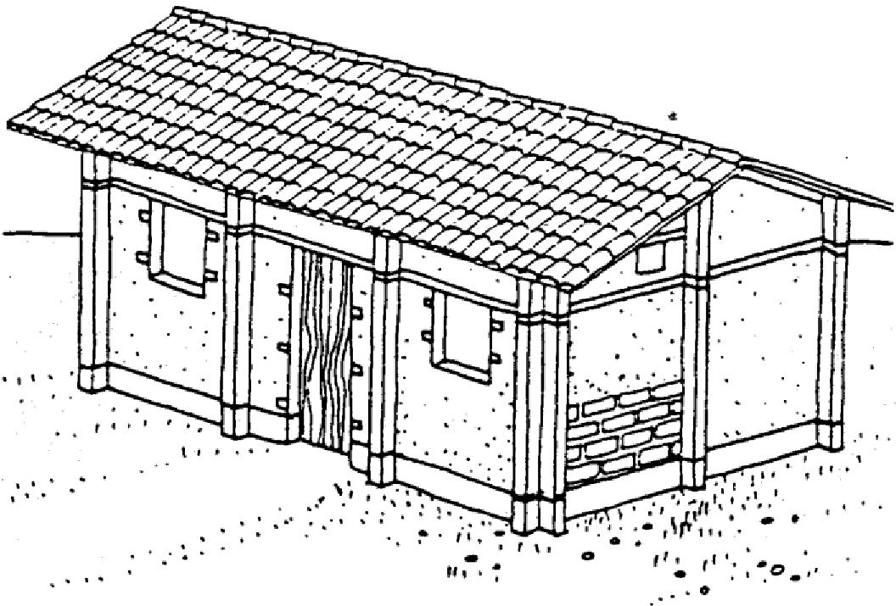
d be built using good quality materials. A low one-storey building in a square (with reinforced corners) or circular shape is best. (Illustrations from Earth Construction: A comprehensive guide by Hugo Houben and Hubert Guillaud. IT Publications, London, 1994.)
Conventional housing In addition to the traditional buildings, there were also many newer, conventional houses. Of these, 5 per cent had galvanized corrugated iron (GCI) sheet roofs on stone walls. GCI sheets were used quite widely in the region, especially to cover semi-open spaces. Unlike RCC, GCI does not radiate heat at night, so quite a few houses had GCI verandas, even though the exclusive use of GCI sheet roofing does not provide the house with adequate thermal insulation. This is an important factor that had to be taken into account during the technology selection process.
RCC-roofed buildings constituted only 3 per cent of the total housing stock, divided equally between houses with earth, brick, and stone walls. Even the earth-walled buildings were built with a fair amount of random stone rubble infill. Brick buildings were the most common addition to urban settlements, especially among the higher income households who were upgrading their homes.
Traditional construction practices were very strong in the Marathwada region, so a few basic principles had to be followed in the design of reconstructed houses, whether they were executed by private sector contractors, government departments, or local artisans.
The following design principles were applied to all categories of buildings. Local buildings and proposed designs that did not match these criteria were either modified or rejected in the public interest:
4
Rebuilding after an earthquake Practical Action

Structural safety. Technologies should be earthquake-resistant to the extent of meeting all the structural requirements of seismic zone 4 in the building standards.
Thermal comfort. Internal comfort had to be maintained, especially keeping the temperature fluctuation to a minimum during the summer months.
Functional efficiency. Buildings should be able to accommodate all the essential functions of current houses, especially the storage of agricultural implements, a separate sleeping area, an independent cooking space, and shelter for animals. These needs determined a minimum area that the basic core unit would occupy. The provision of open, semi-open, and covered spaces should comply with existing practices, as should the layout and clustering of the buildings. Cost effectiveness. Given the above three factors, the most cost- effective technical option should be selected, taking into account the life-cycle cost of the buildings and its durability. Use of local resources. This is a subsidiary constraint which is currently being promoted as the most important factor in technology choice.
The bulk of international experience of reconstruction indicates that the average period of return to permanent dwellings across all documented natural disasters is between one to three years. Hence, the choice of construction technology on the basis of speed of construction is not the most important factor. Many other constraints will delay construction, including the availability of land; sharing and demarcation the plots; infrastructure development; and the resumption of agricultural and other occupations. Speed of construction is probably not going to emerge as a critical constraint.
Community participation. This is an absolutely necessary condition for the success of all relocation and reconstruction programmes, as has been demonstrated in both Indian and international experience. The participation of the local communities in the process of technology choice, decisions on methods of construction, building work, and supervision of works has proved not only to be successful in the long term, but also the most efficient economic option because of increased mobilization of community labour and resources.
Fg g g will
make the wall more stable. (Illustration from Technical Principles of Building for Safety by Andrew Cobum, Richard Hughes, Robin Spence. and Antonois Pomonis. IT Publications, London, 1995.)

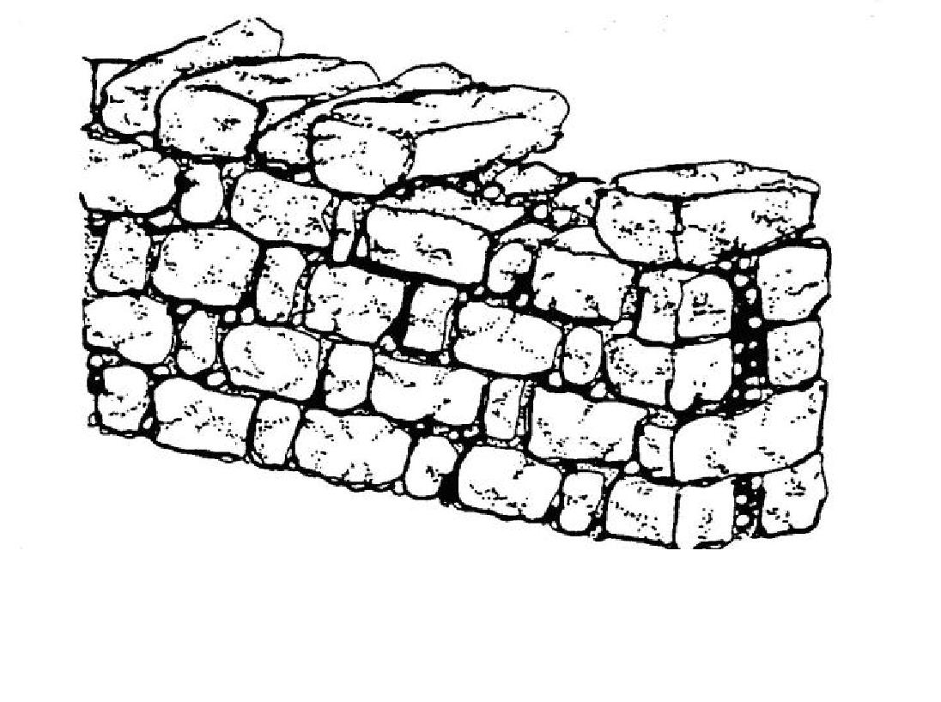
Relocation
People from affected villages wanted to relocate as they felt that their present villages were unsafe. In addition, as they had been forced to cremate or bury the bodies of the earthquake victims in the village itself, they did not want to build on the same site.
Purely in building terms, the relocation of the extensively damaged villages was desirable because:
- In settlements situated on mounds and deep soil areas, future earthquakes were likely to cause severe damage.
- The cost of removing tonnes of rubble could have been exorbitant, especially as any future buildings on these sites were likely to use thin stone walls. As most of the villages were surrounded by good agricultural land, the rubble would have had to have been dumped at a distance of more than 500m
- The cost of building on rocky or hard murram would be much lower, as the foundations could be less than a metre deep
- Drainage systems would be cheaper and sanitation conditions would be much better on sloping shallow soil sites than on flatter land.
Technology interventions areas
Rebuilding after an earthquake Practical Action
5
There were four broad technology intervention areas in the affected districts:

- reconstruction of new buildings on new sites;
- reconstruction of new buildings on old sites (including the recycling of the material);
- strengthening of lightly and moderately damaged buildings in lower intensity zones; and
- retrofitting of undamaged buildings in the region under risk. The main technology intervention in the reconstruction areas was the seismic strengthening of walls and the use of good-quality engineered and non-engineered masonry.
The primary seismic strengthening options were:
- RCC tie beams at lintel and roof level;
- RCC nominal plinth tie beams. Since the new buildings were only single-storey structures that would be used for residential purposes, vertical reinforcements were provided in the comers of the buildings.
The major walling options that were considered were:
- improved coarse random rubble stone masonry in combination mortar (1:2:9 cement:lime:sand) with 45cm wall thickness;
- graded stone concrete block masonry in combination mortar (1:2:9); and
- hollow concrete block masonry in cement mortar (1:6):
In addition, the possibility of improving local stone masonry (with wall thickness of 35 to 45cm) by the use of mud mortar with suitable strengthening was investigated. The strengthening would be provided using lintel beams, RCC roofs, and RCC plinth beams.
The use of brick masonry was ruled out because of the totally inadequate quality of local bricks, which have a crushing strength that is below the accepted engineering standard of 35kg/cm². Three foundations options were considered, including:

- strip footings for murram soil sites;
- strip footings for rocky sites; and
- under-reamed RCC piles with a plinth beam for black cotton soils.
Conclusion
The earthquake in Maharashtra not only had a disastrous effect on the lives of its victims, but was also a catalyst for change in the social fabric of the society. Relocation as part of resettlement (in some cases up to 10km away) distanced the displaced victims from their vital farming lands, and also led to other inevitable adjustments, such as the creation of a new cultural environment, and, in relation to construction, a shift from a rural to a more urban type of housing.
In the aftermath of an earthquake, providing housing is only one essential part of a disaster recovery response. There are also issues of the mental and physical trauma of the victims to be addressed, and rehabilitating the earthquake-affected communities not only materially but also socially and economically.
Civil engineers must join forces with other agents involved in disaster response; consultants, social workers, governmental and non-governmental organizations, and community-based groups in order to ensure that a rehabilitation programme is appropriate and effective. An effective disaster response engineer will be only one part of a wider process of managing the disaster situation, and must co-ordinate and communicate with many of the agencies and individuals involved.
Additional Information Resources
6




Rebuilding after an earthquake Practical Action

- Earthquake-resistant Housing, Practical Action Technical Brief,
- Permanent Shelter For Housing Infrastructure And Services Design - Planning Process,
Practical Action Technical Brief
- Rebuilding Homes and Livelihoods, Practical Action Technical Brief
- Transitional Shelter: Essential criteria to be met, Practical Action Technical Brief
- Earthquake Protection (2nd ed), by Andrew Coburn & Robin Spence, Wiley Blackwell, 2002
- Handbook on Good Building Design and Construction, Aceh and Nias Islands,
International Strategy for Disaster Reduction (ISDR) & United Nations Development Programme (UNDP) Special Unit for South-South Cooperation, 2007,
- Practical Action, South Asia, Guidelines for Planning in the Re-building Process – Resource pack, January, 2004,
- EPC (Environmental Planning Collaborative) / TCG International / FIRE-D (Indo-US Financial Institutions Reform and Expansion) Project, Participatory Planning Guide for Post-disaster Reconstruction, January 2004, (case studies of reconstruction following 2001 Gujarat earthquake in India covering planning and experiences)
- After the Tsunami, Sustainable Building Guidelines for South-East Asia, UNEP SBCI (United Nations Environmental Programme – Sustainable Buildings and Construction Initiative) & SKAT (Swiss Resource Centre and Consultancies for Development), 2007,
- Adapting Traditional Shelter for Disaster Mitigation and Reconstruction: Experiences with community-based approaches, by Theo Schilderman, Building Research & Information, September / October 2004, Vol 32 No. 5, pp. 414-426
- Earthquake Protection for Poor People’s Houses, by Theo Schilderman, Appropriate Technology, Vol. 17 No. 1, 1990, pp. 17-20
- Criteria for earthquake resistant design of structures, Bureau of Indian Standards, IS 1893: 1984; provides guidelines on design in zones of different seismic risk in India. Other relevant Indian Standards include:
- Code of practice for earthquake resistant design and construction of buildings, IS 4326; 1993
- Improving earthquake resistance of earthen buildings – Guidelines, IS 13827: 1993
- Improving earthquake resistance of low strength masonry buildings – Guidelines, IS 13828: 1993
- Guidelines for repair and seismic strengthening of buildings, IS 13935: 1993
- Guidelines for Improving Earthquake Resistance of Housing, produced in India by the Building Materials & Technology Promotion Council (BMTPC),
Guidelines for Building
- Technical Principles of Building for Safety, Andrew Coburn, R. Hughes, A. Pomonis and R. Spence, Practical Action Publishing, 1995.
- Building with Stone and Earth Part 1 & 2, Practical Action Technical Brief
- Seismic Resistant Housing, Pakistan, Article 25, [Online]
- Guidelines for Earthquake Resistant Construction of Non-Engineered Houses,
Earthquake Reconstruction and Rehabilitation Authority (ERRA), Pakistan, 2006
- Shelter Centre Library website
Earthen/Adobe Construction
- Small-scale Manufacture of Stabilized Soil Blocks, ILO; 1987.
- Architecture for the Poor, H. Fathy, University of Chicago, USA, 1973.
- Earth Construction: A Comprehensive Guide, Hugo Houben and Hubert Guillaud, Practical Action Publishing, 1994
- Earth Masonry: Design and Construction Guidelines, Tom Morton, 2008
- Making Stabilised Soil Blocks, Practical Action [Online]
- Galvanised Wire Reinforcement Technology: Earthquake Reinforcement for NonEngineered Stone and Earth Constructions, Sjoerd Nienhuys Huys Advies, 2006
Timber Reinforced Masonry
• Bhartar Construction Timber Reinforced Masonry: An Illustrated guide for Craftsmen, 2007

Rebuilding after an earthquake Practical Action
•
7
Micro Concrete Roofing Tiles
• The Basics of Concrete Roofing Elements, SKAT, 1993
• Product Information: Micro Concrete Roofing Equipment, SKAT, 1997
• Micro-Concrete Roofing Tile Production, Practical Action Technical Brief
People-Centred Reconstruction
• Safer Homes, Stronger Communities: A Handbook for Reconstructing after Natural Disasters, Abhas K. Jha, World Bank, 2010.
• Building Back Better, Michal Lyons and Theo Schilderman (Ed), Practical Action Publishing, UK, 2010.
• Disaster Mitigation – a community based approach, Andrew Maskrey, Oxfam, UK, 1989.
• Disaster Mitigation, Preparedness and Response D Sanderson Practical Action Publishing 1995
• Disaster Risk Management and Reconstruction in Latin America Montoro & Ferradas Practical Action Publishing 2012
• Owner Driven Housing Reconstruction Guidelines, International Federation of Red Cross and Red Cresent Societies (I, 2010
• PCR Tool 1: People-centred Reconstruction (PCR): An Introduction, Practical Action • PCR Tool 8: Participatory Design, Practical Action
• PCR Tool 10: Quality Control, Practical Action
• The Sphere Handbook Sphere Project, Practical Action Publishing 2011
• Emergency Market Mapping and Analysis Toolkit M Albu Practical Action Publishing 2010
This Technical Brief was originally published in the Appropriate Technology Journal.
For more information about Appropriate Technology contact:
Research Information Ltd Grenville Court, Britwell Road Burnham, Buckinghamshire SL1 8DF, UK
Tel: +44 (0)1628 600499
Fax: +44 (0)1628 600488
E-mail: info@researchinformation.co.uk
Website: http://www.researchinformation.co.uk
Website: http://www.researchinformation.co.uk/apte.php
Practical Action
The Schumacher Centre
Bourton-on-Dunsmore
Rugby, Warwickshire, CV23 9QZ
United Kingdom
Tel: +44 (0)1926 634400
Fax: +44 (0)1926 634401
E-mail: inforserv@practicalaction.org.uk
Website: http://practicalaction.org/practicalanswers/
Practical Action is a development charity with a difference. We know the simplest ideas can have the most profound, life-changing effect on poor people across the world. For over 40 years, we have been working closely with some of the world’s poorest people - using simple technology to fight poverty and transform their lives for the better. We currently work in 15 countries in Africa, South Asia and Latin America.

